Device Verification Subsystem 1.0.0

User Guide (Public Web App)

DVS-User-Guide-Public-Web-App-1.0.0

June 19, 2018



Revision history

|  |  |  |
| --- | --- | --- |
| Revision | Date | Description |
| A |  | Initial release |



# **Contents**

1. Introduction 4

1.1. Purpose 4

1.2. Supported Desktop Browsers 4

1.3. Supported Mobile Browsers 5

1.4. Definitions, Acronyms, and Abbreviations 5

2. System Description 6

3. System Navigation 7

3.1. Enter the IMEI 7

Figures

Figure 1 - Check IMEI Status 7

Figure 2 - Device Status 8

Tables

Table 1- Supported Desktop Browsers 4

Table 2- Supported Mobile Browsers 5

Table 3-Definitions, Acronyms, and Abbreviations 5

Table 4-System Description 6

# **Introduction**

The Device Verification Subsystem (DVS) is the subsystem of Device Identification, Registration and Blocking System (DIRBS) .It provides platform for device dealer(s), Mobile User(s) and Authorized entity(s) to check and verify the status of IMEI(s).

The Device Identification, Registration & Blocking System (DIRBS) is a country-wide system deployed in cooperation between the country regulator, operators in that country, and a technology partner that supports deployment. The system checks, identifies, and discourages non-compliant devices by verifying the installed base of devices currently active in a market and continuing to monitor as new devices are activated.

DIRBS can verify that:

* Devices have properly allocated identifiers and type approval
* Devices are not duplicated or stolen
* Device importation takes place through legal channels

## **Purpose**

This document is intended to give assistance to the user to use the Device Verification Subsystem (DVS).

## **Supported Desktop Browsers**

Table 1- Supported Desktop Browsers

|  |  |
| --- | --- |
| **Name** | **Version** |
| Internet Explorer | 11.0 |
| Firefox 52.5 ESR | 57.0 |
| Chrome | 63.0 |
| Safari | 11.0 |
| Edge | 41.16299 |

## **Supported Mobile Browsers**

Table 2- Supported Mobile Browsers

|  |  |
| --- | --- |
| **Name** | **Version** |
| Chrome | 63.0 |
| UC Browser | 11.5 |
| Opera(Android) | 44.1 |
| Opera(iOS) | 16.0.7 |
| Safari | 11.1 |
| Samsung Internet | 6.2 |
| Android | 4.1.x - 4.3 |

## **Definitions, Acronyms, and Abbreviations**

Table 3-Definitions, Acronyms, and Abbreviations

|  |  |
| --- | --- |
| ****Term**** | ****Definition**** |
| **DIRBS** | **Device Identification Registration and Blocking System** |
| IAM | Identity Access Management |
| DVS | Device Verification Subsystem |
| MSISDN | Mobile Subscriber Integrated Services Directory Number |
| IMEI | International Mobile Equipment Identity |

# **System Description**

Table 4-System Description

|  |  |
| --- | --- |
| Feature | ****Description**** |
| Enter the IMEI | Takes the valid IMEI as input. Enter IMEI of device to be verified |
| RECAPTCHA | RECAPTCHA is used in order to protect the system from the bots(-bot-is a software application that runs automated tasks (scripts ) over the internet ) |
| Device Status | Display the relevant device details (IMEI, Brand, Model Name, IMEI Compliant Status etc.) in a table |

# **System Navigation**

## **Enter the IMEI**

1. Enter the IMEI

**Note**: IMEI can be of alphanumeric characters (0-9, A-F, a-f). The length of the IMEI should be between 14-16 characters.

1. Click on the RECAPTCHA checkbox, complete the verification process (if applicable )
2. Click on the “Submit” button

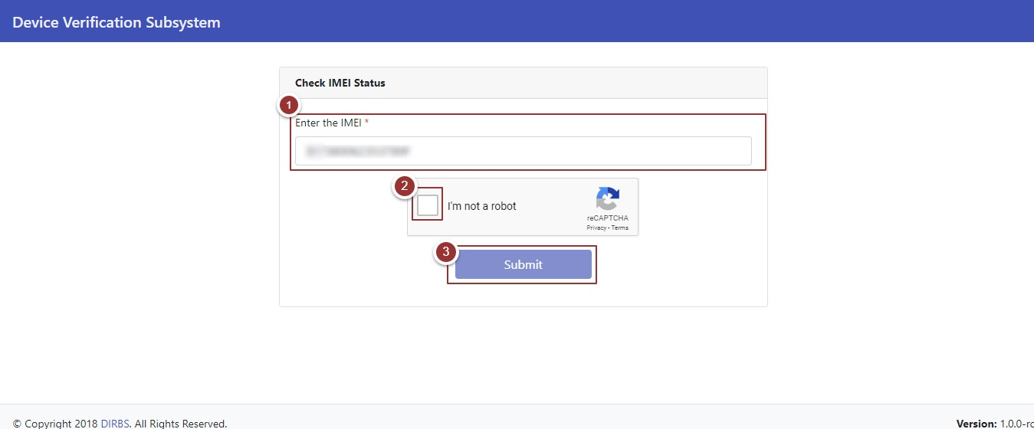Figure 1 - Check IMEI Status

After clicking on the “Submit” button, status of the device (i.e. IMEI, Brand, Model Name, IMEI Compliance Status etc.) will display in a table.

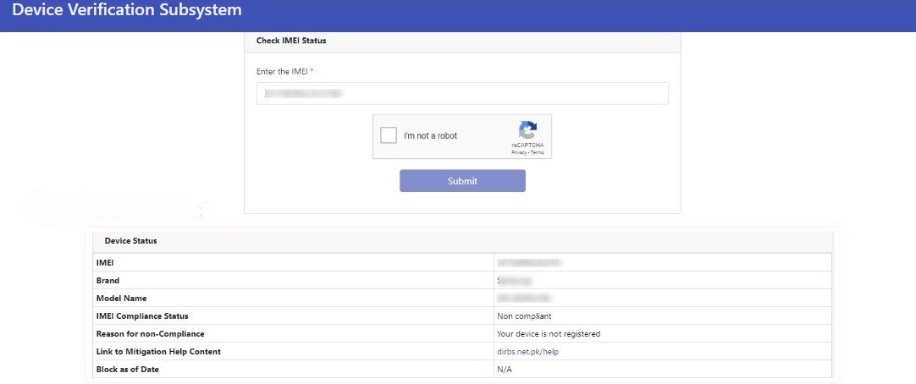Figure 2 - Device Status